La CASA Kitchen Manual
Updated: October 10, 2025
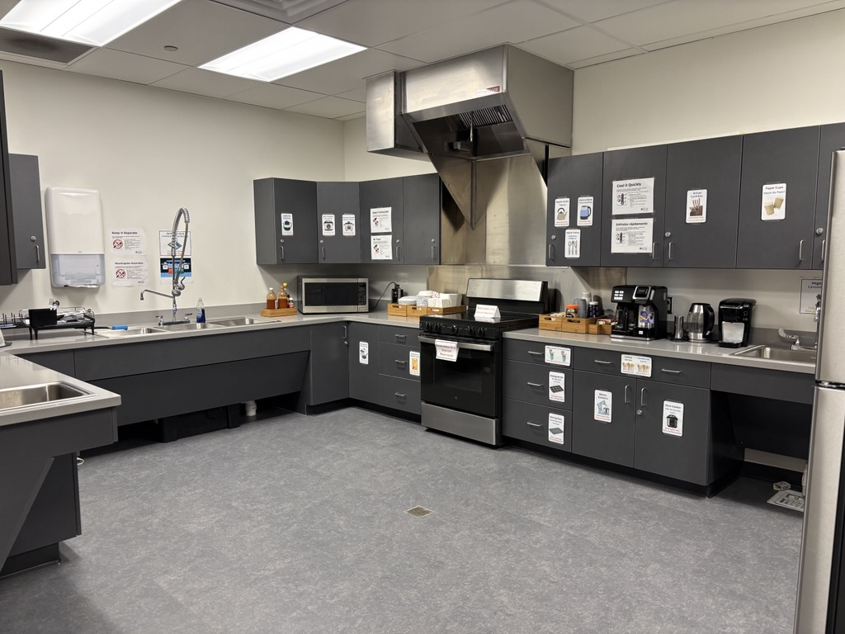

Table of Contents
- Introduction
- Objective
- Contact Information
- Fiscal Accountability and Budget
- Equipment
- Kitchen Use Overview
- Cleaning and Sanitation
- Training and Safety
- Columbia Basin College’s Policies and Procedures
- Evaluation

Introduction
La CASA’s Kitchen is the first communal kitchen facility available to students and employees at Columbia Basin College (CBC). The kitchen is located within the Pasco campus T-Building, Room T408. La CASA’s Kitchen Manual will serve to assist CBC employees in understanding and implementing the regulations for use, cleaning, safety protocols, budget, and documentation of the kitchen’s use.
This manual serves as a resource document in carrying out the approved Plan of Operation as approved by Cabinet and guided by the La CASA’s Kitchen Planning Team. It is designed to provide specific procedures and protocols unique to La CASA’s Kitchen, to support the proper monitoring and evaluation of its use, and ensure the appropriate expenses are documented for uninterrupted services to students and employees. Revisions or additions to this manual must be approved by La CASA’s Kitchen Planning Team and Cabinet.
All employees who intend to use La CASA’s Kitchen must become familiar with the information included herein, stay up to date on the regulations and protocols, and ensure safety procedures remain at the forefront while the kitchen is in use. All employees involved with oversight of the kitchen should refer to this manual to reference expectations of the kitchen’s use. Questions concerning La CASA’s Kitchen matters should be directed to La CASA’s Director.

Objective of the Kitchen
La CASA was designed to align with the college’s Hispanic Serving Institution designation, the Title V Grant goals, and CBC’s Inclusivo Strategic Plan. La CASA is committed to fostering a sense of belonging, empowerment, and community for individuals of all backgrounds. La CASA strives to foster student engagement, support academic success, and empower students to thrive both socially and professionally.
As part of La CASA, its kitchen will provide an opportunity to respond to food and housing insecurity, and to create community amongst students and employees. With these efforts in mind, La CASA’s Kitchen will provide equitable and culturally sustaining practices aimed at student success.

Contact Information

Key Personnel
Jennifer Castro-Velazquez, Director for La CASA & Title V Grant
Jcastro-velazquez@columbiabasin.edu|509.544.2036
Michael Jaramillo, La CASA Program Coordinator
mmjaramillo@columbiabasin.edu|509.542.4444
General Inquiries - La CASA Email
lacasa@columbiabasin.edu

La CASA’s Kitchen Planning Team
Alex Thorton
Alicia Briones
Amanda Orellana
Benjamin Bush
Jennifer Castro-Velazquez
Kirk Engle
Leslie Guzman
Luz Gutierrez
Melisa Cedeño
Michael Jaramillo
Michelle Stewart
Rosario Rodriguez
Sheyenne Coffland
Steven Schneider
Teresa Iztas

Fiscal Accountability and Budget

Fiscal Control of La CASA’s Kitchen Funds
Columbia Basin College’s Business Office will allocate funds for La CASA’s yearly budget, including a line item for La CASA’s Kitchen expenses. La CASA’s Director will work in coordination with the Business Office to oversee the management and accounting for use of all funds dedicated to the operational use of La CASA’s Kitchen. Funds will be committed to La CASA and its Kitchen as part of La CASA’s yearly budget approved by Cabinet.

Purchasing
The purchasing of supplies, services, and equipment must conform to those items listed in La CASA’s Kitchen budget. All expenditures submitted to La CASA’s Director for payment must show justification of purchase and should be tied to the Kitchen’s Objective.

Budget

Annual Budget Submittal
La CASA's Director will submit a budget proposal for La CASA Kitchen’s use to Cabinet and receive an approved budget. La CASA’s Director may complete the Budget Enhancement process as needed.

Planning and Managing Budgets
La CASA’s budget and estimated costs must include a quote from an approved vendor. La CASA’s Kitchen Budget will cover the following items yearly: Cleaning Materials, Appliances and Utensils, and Cooking Ingredients for Cooking Demonstrations.
It is La CASA’s Director’s responsibility to monitor the budget for expenditures and to ensure they are posted to the correct line-item account. Copies of expenditure documentation (requisitions, purchase orders, and invoices) are to be kept on file. La CASA’s Program Coordinator should forward to La CASA’s Director, for filing on a monthly basis, any requisitions, purchase orders, and invoices processed for the Kitchen.

Expending Carryover Funds
Unexpended funds do not carry over and are not guaranteed in the following fiscal year.

Equipment
La CASA received funds from the Workforce Education Center’s Free and Reduced Price Lunch (FRPL) State Allocation to purchase initial appliances and disposable kitchen materials to support the opening of La CASA’s Kitchen and to address food insecurity within the student population. FRPL Funding is not guaranteed for future years, and La CASA’s budget will be charged as needed for the replacement of additional equipment and disposable kitchen materials throughout the years.
La CASA’s Budget line for the Kitchen will be used to purchase cleaning materials for the Kitchen. Cleaning materials will be added to the equipment inventory system.
La CASA Employees will maintain the official equipment inventory system, and update inventory identification tags as needed. La CASA’s Kitchen materials purchased with FRPL funds, will be labeled as such. An inventory of all Kitchen equipment must be conducted on a quarterly basis, and condition, as well as quantity, must be updated. Kitchen equipment cannot be moved and/or discarded without documentation by La CASA employees.

Kitchen Use Overview
The kitchen will be open to all students and employees to utilize during La CASA’s Hours of Operation. La CASA’s Kitchen will be available for use through:
1.) General use as limited by on-the-counter, low-risk kitchen appliances
2.) Reservations with open access to all kitchen appliances overseen by a trained employee member.
All food prepared in La CASA’s Kitchen is considered food for a private event, in accordance with regulations from the Department of Health. This means that food cooked either individually during general use or through a reservation can only be consumed by those who cooked it or were part of the reservation process. Food prepared in the kitchen is NOT to be shared with the general public. The general public is considered any person who is not registered/affiliated with the reserving group. There is a maximum capacity of three (3) people in the kitchen at a time. Groups greater than 3 people can cycle between participants to ensure they meet maximum capacity regulations.

General Use Only
During La CASA’s Hours of Operation (see La CASA’s Webpage for current hours), La CASA’s Kitchen will be open for general use by all students. Students should limit their use of the kitchen to a maximum of 40 minutes at a time.
Students may use the following on-the-counter and low-risk appliances for individual cooking needs:
- Sinks
- Refrigerator
- Microwave
- Toaster
- Coffee Machines
- Electric Kettle
- Ice Machine
- Disposable plates, bowls, cutlery
Students are responsible for cleaning up after themselves and each appliance they use. Cleaning materials will be readily available to students. By using the kitchen, you agree to the rules and procedures of the kitchen listed below.

Reservations
Students interested in participating in cooking a shared meal or viewing a cooking demonstration must be supervised by an employee.
La CASA’s Kitchen may be reserved for cooking demonstrations and meals by employees who have completed the required training listed below under Training and Safety. The employee who creates the reservation will be present, oversee the cooking process, and understand and ensure safety and cleaning regulations are followed during kitchen use.
Food prepped/made in La CASA’s kitchen cannot be used for fundraising purposes. Food served out of La CASA’s kitchen cannot be publicly advertised (i.e., social media posting) unless food is prepared by a licensed and insured caterer.
Reservations are available during La CASA’s Hours of Operation and should be reserved for a minimum of two (2) weeks in advance of the reservation date. Reservations should not exceed four (4) hours of use, unless approved by La CASA Staff.
Employees and students using La CASA’s Kitchen through the reservation process may use the following appliances:
- All appliances listed in ‘General Use Only’ section
- Stovetop
- Oven
- Knives
- Rice Cooker
- Hot Plates
- Pots and Pans
- Cutting Boards
- All additional appliances with La CASA’s Kitchen Inventory
Employees and students are responsible for cleaning and sanitizing the kitchen appliances and materials they use during their reservation. Cleaning materials will be readily available to use.

Reservation Process
- Availability of La CASA’s kitchen can be viewed through 25Live here.
- Employees must have completed the required Kitchen Safety Trainings and have an up-to-date Food Handler’s Card from the Department of Health prior to reserving La CASA’s Kitchen.
- Employees interested in using La CASA’s kitchen should complete this reservation form. Confirmation of training need to be attached to the reservation along with waivers for students who will be accessing the kitchen.
- Employees may only reserve the kitchen for demonstration or meal sharing for or amongst students.
- Requests must be completed at least two (2) weeks before the event takes place.
- On the day of the event, La CASA employees will complete a walk through with the employee who completed the reservation, ensuring they know the location and of all the kitchen appliances/utensils and cleaning materials.
- Prior to the conclusion of the reservation, La CASA employees will complete a final walkthrough to ensure the kitchen appliances/materials have been properly stored and that the kitchen is thoroughly cleaned and sanitized.
By using the kitchen, you agree to the rules and procedures of the kitchen listed below.

Rules and Procedures for Kitchen Use
The following rules must be observed while using the kitchen. Rules are strictly enforced, and failure to comply with them will result in loss of access to the kitchen.
- Ensure that you have checked into La CASA at the front desk kiosk.
- Up to a maximum of three (3) people may be in the kitchen at a time. Groups of more than 3 people may rotate in and out of the kitchen to allow for participation in cooking and demonstrations.
- Read and follow all the kitchen signs.
- ‘General Use Only’ appliances are the only appliances available to students without reservation. All other appliances require reservations.
- An employee or student should always be present in the kitchen when appliances are in use. Do not leave the kitchen unattended while cooking.
- Do not remove any appliances or other kitchen materials from the kitchen.
- Sponges are only to be used for dishes, silverware, pots, pans, and other cookware. Separate cleaning materials will be available for countertops and floors.
- All dishes, silverware, pots, pans, and other cookware used during reservations should be washed and sanitized through the 3-compartment sink sanitization process.
- Food stored in the kitchen must be properly stored and labeled with the date the food was made and the name of who the food belongs to. Food that is unproperly stored or labeled will be thrown away at the end of the day.
- Food that has been left within the fridge or kitchen by the end of the week will be thrown away each Friday (or last day of the week) unless noted otherwise.
- Plates, bowls, cups, Tupperware, and any other kitchen material brought in from home should be returned home or noted as a donated item to La CASA’s Kitchen.
- Do not eat what is not yours. Respect other people’s labeled foods.
- Any messes made while utilizing the kitchen must be cleaned before you leave the kitchen.
- Empty and clean toaster, microwave, or other ‘General Use Only’ at the end of the day.
- Complete the cleanup checklist BEFORE your reservation slot is over.

Cleaning and Sanitation

General Cleaning
La CASA Employees and Student Workers will be responsible for surface level cleaning at the end of each week, however the major responsibility for upholding cleanliness falls upon students and employees who use the kitchen. The Cleaning Checklist below is expected to be followed daily.

Facilities will complete general cleaning duties such as trash removal, however more in-depth cleaning needed for the kitchen will need to be requested through work orders.

Cleaning Checklist
The following list must be complete before reservations or general use ends:

- Turn off all appliances.
- Any grease produced in the kitchen, should be disposed of properly in the provided grease disposal container. This container is emptied weekly by La CASA employees. If the container needs to be emptied, please let the front desk know. Grease should never be disposed of in sinks or the garbage can.
- Wipe out the microwave after use particularly if your food splattered inside.
- Wash and sanitize all used items and do not leave anything in the sink.
- Wipe down and clean all surfaces, including the stove, microwave, counters, table, and the floor.
- If you use a sponge, please rinse and wring it out before putting it away.
- No food items should be left out.
- If you are leaving leftovers in the fridge or pantry, please label them with your name and be sure to pick them up before the end of the week. If they aren’t stored or picked up, they will be tossed.
- Complete the checklist and turn it in to La CASA at the front desk.
- Inform La CASA employees if any of the kitchen supplies (paper towels, sponges, soap, etc.) have been used up or are running low or if any items were broken or damaged during use.

Sanitation Process – Three Sink Method
The three-sink method is the manual procedure for cleaning and sanitizing dishes, typically found in commercial settings. Although not a commercial kitchen, La CASA’s Kitchen will follow the same process as multiple people and foods will be in contact with this communal kitchen. The three compartments allow employees and students to wash, rinse, and sanitize dishes. Each step has its own set of rules and requirements.

Important: Never use the three compartments sink for anything other than cleaning, rinsing, and sanitizing dishes. Hand washing or dumping of mop water is not permitted in the three-compartment sink. Each sink will be labeled to help employees and students remember the sink order. Dishwashing gloves will be provided to protect employees and students’ hands throughout this process.

Guidance for use of this sanitation method derives directly from WebstaurantStore.com, all information can be found in detail here:
3 Compartment Sink Rules & Proper Use - WebstaurantStore.

Three Compartment Sink Order
- Sink 1 = Wash
- Sink 2 = Rinse
- Sink 3 = Sanitize

Three Compartment Sink Steps
- Remove food: Scrape leftover food off the dishes.
- Scrub: Use the first sink to scrub the dishes in soapy, warm water (minimum temperature of 110 degrees Fahrenheit required).
- Rinse: Use the second sink to rinse the dishes in clean, warm water (minimum temperature of 110 degrees Fahrenheit).
- Soak: Use the third sink to soak the dishes in a chemical sanitizing solution. Refer to the directions provided by your chosen sanitizer to determine how long the dishes need to remain submerged. Alternatively, you can use hot water at 171 degrees Fahrenheit or hotter instead of sanitizing chemicals. If you choose to sanitize in hot water, leave the dishes sitting in the scalding water for a minimum of 30 seconds.
- Dry: Always air-dry the dishes. Otherwise, you risk recontamination.

Important: Replace the water whenever it appears dirty.

Water Temperature in a Three Compartment Sink
The required water temperature in a three-compartment sink depends on the sink you’re filling. The water in the first and second sink needs to be a minimum of 110 degrees Fahrenheit to meet the FDA requirements. If you plan to use water in your third sanitizing sink, the water must be 171 degrees Fahrenheit or hotter.

Important: Use a thermometer to check the water temperature.

Three Compartment Sink Sanitizer Temperature
The selected sanitizer for La CASA’s Kitchen is chlorine bleach. You must leave the dishes submerged in the sanitizer for at least one minute. Chlorine bleach requires a temperature of 75-120 degrees Fahrenheit. Chlorine bleach shall be diluted 50 or 100ppm within the three-compartment sink.

Training and Safety

Students
Students using La CASA’s Kitchen are responsible for using all kitchen materials correctly and assume responsibility for their own safety while in the Kitchen. Without employee supervision, students using La CASA’s Kitchen under ‘General Use Only’ (listed under Kitchen Use Overview) are limited to use of low-risk items. Appliances and other materials available through the ‘Reservations’ process will be locked away and/or labeled as ‘Reservations Use Only. CBC is not liable for any incidents that occur within La CASA’s Kitchen.

All students who use La CASA agree to La CASA’s Community Agreements when they check in through our SARS-Trak System. A new agreement was added in connection to the kitchen use, and reads as the following:

‘By using the community kitchen, you agree to take personal responsibility for your own safety and actions. The College is not liable for any injuries, damages, or losses that may occur while using this space or its equipment.’

The full list of La CASA Community Agreements can be found on La CASA’s webpage.
Students who participate in La CASA through the reservation process must complete a Release of Liability and Consent to Treat Waiver. Students under the age of eighteen (18), must receive parent/guardian signature. Student waivers are valid for two (2) years. A new waiver must be completed prior to the 2-year mark for continuous access to La CASA’s kitchen.

Employees
Prior to reserving La CASA’s Kitchen, employees are responsible for completing training for La CASA’s Kitchen. Training will be completed through CBC’s Environmental Safety and Health and through Washington’s Department of Health. Training will be valid for 2 years from completion date of initial training and must be completed prior to the 2-year mark for continuous of access.

Training though Environmental Safety and Health include:
- Safety Skills - Kitchen Equipment Safety
- Safety Skills – Food and Safety for Food Service: Cleaning and Sanitation
- Safety Skills – Ladder Safety: Safety Use
- Fire Extinguisher K-Class Video
- Evacuation Routes

Training though Washington’s Department of Health include:
- Food Worker Card: www.foodworkercard.wa.gov

For additional information about food safety in Washington you may review:
Food Safety Rules and Regulations: Food Safety Rules and Regulations | Washington State Department of Health

Employees are responsible for knowing which students will be present and using the kitchen during their reservation timeframe. Each student using La CASA’s kitchen must complete a Release of Liability and Consent to Treat Waiver. Students under the age of eighteen (18), must receive parent/guardian signature. Student waivers are valid for two (2) years. A new waiver must be completed prior to the 2-year mark for continuous access to La CASA’s kitchen.

Employees using La CASA’s Kitchen are responsible for using all kitchen materials correctly and are responsible for their own safety while in the Kitchen.

Appliances and other materials available through the ‘Reservations’ process will be locked away and/or labeled as ‘Reservations Use Only. CBC is not liable for any incidents that occur within La CASA’s Kitchen.

Columbia Basin College’s Policies and Procedures

Liability
Columbia Basin College is not liable for any incidents that occur within La CASA’s Kitchen.

Conduct within La CASA should follow the same Code of Conduct that students adhere to throughout campus.

Policies and Procedures
For additional information, please refer to CBC’s Webpage:
Student Conduct.

Evaluation

Monthly Reports
Data regarding La CASA’s Kitchen use will be recorded throughout La CASA’s Monthly Reports. Recorded information will include the number of students who checked in to use La CASA’s kitchen and the reservations completed. Reservation data will include how many students participated per reservation and the department(s) who participated. This information will be used by La CASA Staff to champion student access and advocate around basic needs for equitable and culturally sustaining practices aimed at student success.

