Logistics and Supply Chain Articulation Agreement Between Lake Washington Institute of Technology and Columbia Basin College

This Articulation Agreement (the “Agreement”) is entered into by and between Lake Washington Institute of Technology and Columbia Basin College, each individually a “Party” and collectively the “Parties”. This Agreement shall have an effective date (“Effective Date”) as of the last signature received.

The Parties wish to collaborate in order to facilitate the transfer and degree completion of students earning the Associate in Applied Science - Transfer (AAS-T) in Logistics and Supply Chain Resilience at Columbia Basin College to the Bachelor of Applied Science (BAS) in Transportation, Logistics and Supply Chain at Lake Washington Institute of Technology. This agreement formally recognizes that Columbia Basin College and Lake Washington Institute of Technology are both active educational partners in providing opportunities for currently enrolled and potential students of their combined institutions. Both institutions commit to facilitating the transfer of students with approved associate degree programs into approved baccalaureate degree programs without jeopardizing the intended mission and stated goals of either institution.

This agreement is specifically designed to increase educational opportunities for students, allow for the maximum transfer of credit between schools, aid in a seamless transition from one program to another, and lift enrollment at both Lake Washington Institute of Technology and Columbia Basin College. To support these goals, both schools agree to maintain a course-by-course evaluation of comparable classes and distribution requirements.

The Parties enter into this Agreement in the spirit of cooperation and mutually recognize each other as quality postsecondary institutions.
NOW, THEREFORE, the Parties agree as follows:

Transfer Credit
Lake Washington Institute of Technology agrees to transfer Columbia Basin College credit using the criteria outlined below:
Completion of the AAST in Logistics and Supply Chain Resilience at Columbia Basin College with an overall minimum 2.0 GPA in all coursework will satisfy 90 credits required by the program.

Completion of three prerequisite courses. All of those are included in Columbia Basin College’s AAS-T in Logistics and Supply Chain Resilience:

Lake Washington Institute of Technology | Columbia Basin College
MATH& 107 or any college-level  math course with Intermediate Algebra as a prerequisite | MATH& 107 or above
ENGL& 101 | ENGL& 101
Any Social Science | Any Social Science

Additional credits may be accepted for courses other than those listed that meet Lake Washington Institute of Technology’s standard polices on transferable credits. Those credits may be applied toward general education requirements, program requirements, or general electives as appropriate.
Students must earn a minimum of 180 credits total from all sources to earn the BAS degree. See Appendix A.

Admission to Lake Washington Institute of Technology
It is agreed that those students who receive the AAS-T in Logistics and Supply Chain Resilience at Columbia Basin College and meet all of the criteria listed above will be accepted without further review at Lake Washington Institute of Technology into the BAS in Transportation, Logistics and Supply Chain. However, final admission to Lake Washington Institute of Technology is contingent on submission of:
  - A completed general Lake Washington Institute of Technology admission form
  - A completed Transportation, Logistics & Supply Chain Bachelor of Applied Science application form
  - Official transcripts from Columbia Basin College

Participant Criteria
The criteria that shall be met by students seeking to participate in the Agreement are as follows:
  - Students must meet all program requirements prior to receiving the Bachelor of Applied Science in Transportation, Logistics and Supply Chain
  - Students who elect to pursue a different degree program at Lake Washington Institute of Technology will be subject to re-evaluation of transferrable credits and will forfeit any credits not transferrable to Lake Washington Institute of Technology outside of this agreement per standard policies on credit transfer.

Columbia Basin College’s Obligations
Columbia Basin College agrees to use reasonable efforts to:
  - Make promotional materials and information available to its students regarding the Lake Washington Institute of Technology Bachelor of Applied Science in Transportation, Logistics and Supply Chain program, including flyers, invitations to campus events, and emails to the prospective Supply Chain Resilience AAS-T graduates
  - Provide opportunities for a representative from Lake Washington Institute of Technology to interact with potential students

Lake Washington Institute of Technology’s Obligations
Lake Washington Institute of Technology agrees to use reasonable efforts to:
  - Provide support material to include transfer guides, admission applications, course catalogs, and reports on transfer student activities
  - Provide representation at recruitment events

The Parties’ Joint Obligations
Lake Washington Institute of Technology and Columbia Basin College agree to use reasonable efforts to:
  - Provide links on their institutional websites indicating the existence of this agreement
  - Exchange data and documents that will contribute to the maintenance and improvement of this articulation agreement and promote effective cooperation between the two institutions
  - Undertake an annual evaluation of the partnership supported by this articulation agreement and use the findings to improve the transfer process for students. Any written materials published and distributed by Lake Washington Institute of Technology and/or Columbia Basin College which specifically references the articulation agreement between the two institutions or makes any general representation of each other’s institution, must be approved by each respective party prior to its use.

Review & Termination
The term of this Agreement shall be for three (3) years, beginning on the “Effective Date”. The Parties agree to review this Agreement and the Program once during this period at a time mutually convenient for the Parties but aiming for during the 2nd year of this agreement’s term. Notification of revisions to Lake Washington Institute of Technology’s current and anticipated course offerings will also be sent to Columbia Basin College during the above review period. A Letter of Review will be sent between 30 and 60 days prior to agreement expiration to ensure both parties can continue to fulfill the terms of this agreement or if revisions may be required. This Agreement can be terminated by either party by giving written notice to the other party’s designated representative at least 60 days prior to the commencement of a new academic quarter.

Non-Discrimination
Neither party shall discriminate against any person on the basis of race, color, national origin, age, perceived or actual physical or mental disability, pregnancy, genetic information, sex, sexual orientation, gender identity, marital status, creed, religion, honorably discharged veteran or military status, or use of a trained guide dog or service animal, as required by Title VI of the Civil Rights Act of 1964, Title VII of the Civil Rights Act of 1964, Title IX of the Educational Amendments of 1972, Sections 504 and 508 of the Rehabilitation Act of 1973, the Americans with Disabilities Act and ADA Amendment Act, the Age Discrimination Act of 1975, the Violence Against Women Reauthorization Act and Washington State’s Law Against Discrimination, Chapter 49.60 RCW and their implementing regulations.

Notices
All notices concerning this memorandum of agreement and understanding shall be in writing and will be considered to have been given at the time of receipt of notice by the other Party.
- Notices to Columbia Basin College:

Dr. Kyle Winslow
Dean for Business and Computer Science Columbia Basin College
- Notices to Lake Washington Institute of Technology:

Heather Sneed
Associate Dean of Business
Lake Washington Institute of Technology

Independence of the Parties
The Parties are independent institutions. Nothing contained in this Agreement will constitute either Party the agent, partner, or legal representative of the other Party for any purpose or constitute the Parties as partners. Neither Party has any right, power, or authority to create any obligation or responsibility on behalf of the other.

The Parties have signed below to indicate their acceptance of the terms of this AGREEMENT.

Signatures:
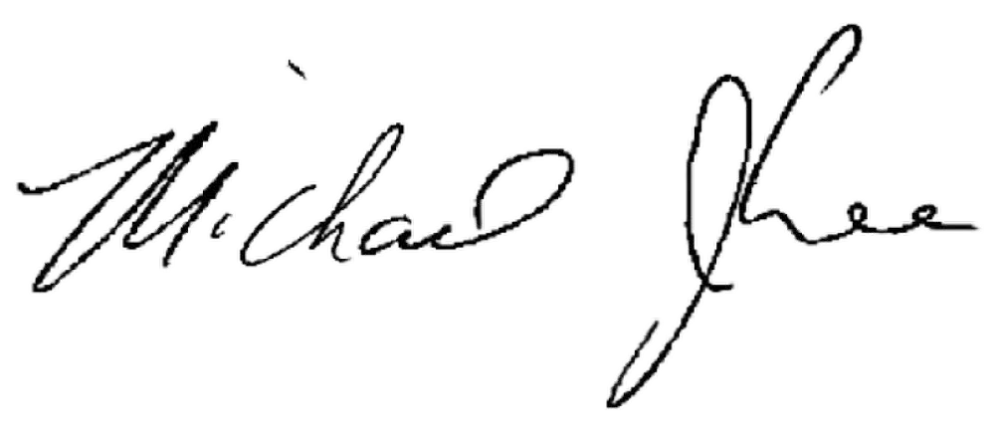
Dr. Michael Lee
June 3, 2025
Date
Vice President for Instruction, Columbia Basin College
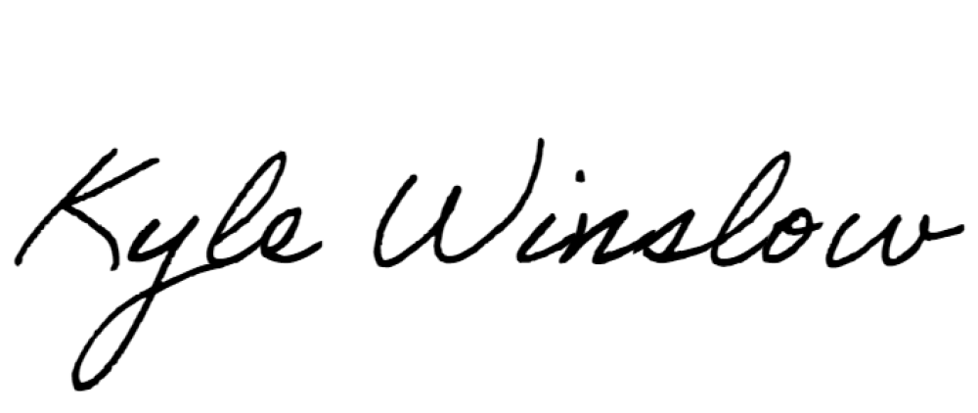
Dr. Kyle Winslow
May 19, 2025
Date
Dean for Business and Computer Science

Ruby Hayden (Jun 4, 2025 17:04 PDT) 06/04/2025

Dr. Ruby Hayden Date
Vice President of Student Services, Lake Washington Institute of Technology

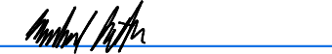
Mike Potter (Jun 9, 2025 17:39 PDT) 06/09/2025

Dr. Mike Potter Date
Vice President of Instruction, Lake Washington Institute of Technology

Columbia Basin College and
Lake Washington Institute of Technology
Appendix A: Fall 2025

LWTech Requirements | Credits | Columbia Basin College equivalent | Credits
Applied Associate’s technical courses | 55 | AAS-T in Logistics and Supply Chain Resilience | 55
Required Prerequisites
MATH/MATH&  (any with Intermediate Algebra pre-req) | 5 | MATH/MATH& (any with Intermediate Algebra  pre-req) | 5
ENGL& 101 English Composition I | 5 | ENGL& 101 English Composition I | 5
Social Science | 5 | Any class designated as a Social Science
General Education:
ECON 310 Business Economics | 5 | must be taken at LWTech | 5
ENGL& 102 English Composition II or ENGL& 235 Technical Writing | 5 | ENGL& 102 English Composition II or ENGL& 235 Technical Writing | 5
Humanities | 5 | Any class designated as a Humanity | 5
MATH 246 Business Statistics | 5 | must be taken at LWTech | 5
Natural Science course with Lab | 5 | Any class designated as a Natural Science w/ a Lab | 5
PHIL 305 Professional Ethics | 5 | must be taken at LWTech | 5
Social Science | 5 | ECON& 201 Micro Economics or ECON& 202 Macro Economics, or any class designated as a social  science | 5
Subtotal | 50 | Subtotal | 50
TLSCM Core Program
ACCT& 201 Principles of Accounting I | 5 | ACCT& 201 Principles of Accounting I | 5
ACCT 301 Managerial Accounting | 5 | must be taken at LWTech | 5
BUS& 201 Business Law | 5 | BUS& 201 Business Law | 5
BUS 320 Principles of Management | 5 | must be taken at LWTech | 5
TLM 301 Introduction to Logistics Management | 5 | must be taken at LWTech | 5
TLM 302 Airline, Airport, and Seaport  Management | 5 | must be taken at LWTech | 5
TLM 304 Domestic and International Freight Management | 5 | must be taken at LWTech | 5
TLM 421 Supply Chain Analytics for Managerial  Decision Making | 5 | must be taken at LWTech | 5
TLM 306 Quality and Operations Management | 5 | must be taken at LWTech | 5
TLM 308 Procurement and Supply Management | 5 | must be taken at LWTech | 5
TLM 414 Principles of Marketing | 5 | must be taken at LWTech | 5
TLM 415 Supply Chain Management and Technologies | 5 | must be taken at LWTech | 5

TLM 422 Finance Principles | 5 | must be taken at LWTech | 5
TLM 435 Shipping and International Logistics | 5 | must be taken at LWTech | 5
TLM 444 Capstone Project/Strategic Management | 5 | must be taken at LWTech | 5
Subtotal | 75 | Subtotal | 75
Total | 180 |  | 180
2024-2025

